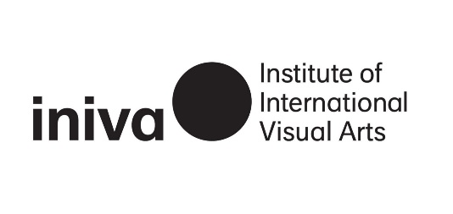

On Our Table: Art Pedagogy
Reading List

The following reading list was created on occasion of the lunchtime talk On Our Table: Art Pedagogy held at Stuart Hall Library, 14 March 2024, and spotlights materials from the library and archive, examining how books and resources can act as aids for educational practices and artistic expression.

LIBRARY | SHELF LOCATION
This Paper is Intentionally Blank  By Geoff Cox, Victoria de Rijke and Sophie Weeks  London: Camerawork, 1996. | AB COX
Schooling & Culture  Vol. 2, issue 1, Spring 2017  London: Calverts Co-Operative: Design and Print, 2016. | Journals
Filter: an Interactive Teaching Resource  By Mary Evans  London: iniva (Institute of International Visual Arts), 1999. | CD 50
The Funambulist  No. 49 Schools of The Revolution (September-October 2023)  Paris: The Funambulist, 2023. | Journals
The Artpack: a History of Black Artists in Britain  By Eddie Chambers, Juginder Lamba and Tam Joseph  London: Chambers & Joseph | 410 ART
Teaching to Transgress : Education as the Practice of Freedom  By bell hooks  New York: Routledge, 1994. | ESS HOO
Claudette Johnson: Pushing Back the Boundaries  By Lubaina Himid  Hebden Bridge: Urban Fox Press, 1990 | AS JOH
On Being Included: Racism and Diversity in Institutional Life  By Sara Ahmed  Durham, London: Duke University Press, 2012. | ESS AHM
In and Out of Africa: The Guide to Gallery Education in London  London: NAGE, 1995. | ESS INA (Oversized)
Another Country: A Year Long Arts Education Project in Great Alne, Warwickshire  Artists in Warwickshire Education (AWE), Iniva (Institute of International Visual Arts) and Rugby Art Gallery and Museum  Artists in Warwickshire Education, 2005. | 410.186 ANO (Oversized)
Arts Education for a Multicultural Society: An Evaluation of the AEMS Project  Edited by John Eggleston  Stroke-on-Trent: Trentham Books, 1995 | ESS ART
Sources: An Information Pack for Colleges and Universities on Contemporary and Modern Art in Africa  By Rohini Malik  London: Whitechapel Art Gallery in collaboration with iniva (Institute of International Visual Arts) | ESS SOU
On Care  Edited by Rebecca Jagoe & Sharon Kivland  MA Bibliothèque, [2020] | ESS ONC
DARE: Primary CD-Rom  By Rebecca Sinker  London: iniva (Institute of International Visual Arts), 2003 | ESS DAR
Creative Mapping: A Zine for the Youth Rising Programme 2023  Edited by Kalpana Arias  London : iniva (Institute of International Visual Arts), 2023 | ZIN CRE
CoLab: Embodied Healing  By Fauziya Jonson and Kiara Mohamed Amin  London: iniva (Institute of International Visual Arts), 2023 | ZIN JOH
You Can’t Ignore Us: a Zine Created by Young People from Castleford for CoLab Wakefield 2023  London: Institute of International Visual Arts, 2023  Blue Portal  London: Institute of International Visual Arts, 2024  Portraiture education pack  By Rohini Malik  London: Institute of International Visual Arts, 1995  Landscape education pack  By Rohini Malik  London: Institute of International Visual Arts, 1995  What do you feel? : emotional learning cards  By Lyn French  London: A Space, 2008  Who are you? Where are you going? : emotional learning cards  By Lyn French  London: A Space, 2014  How well do we live with others? : emotional learning cards  By Lyn French  London: A Space, 2014  Journal Articles  Gudskul by Annie Jael Kwan  Art Review Asia, vol. 7, no. 4, pp. 60-65. | ZIN YOU  ZIN BLU  RP POR  RP LAN  RP WHA  RP WHO  RP HOW
Self-organize and Self-educate by Liang Jianhua
Art Asia Pacific, issue 127, p. 24.

Decolonising the Canon by Virginia Whiles
Art Monthly, no. 429, pp. 6-9.

