Black Visual Sound Practices

GRIME PLAYLIST

- M Beat featuring General Levy, Incredible (1994)

- Shy FX & UK Apache, Original Nuttah (1995)

- Oxide & Neutrino, Bound 4 Da Reload (2000)
Scan the QR Code
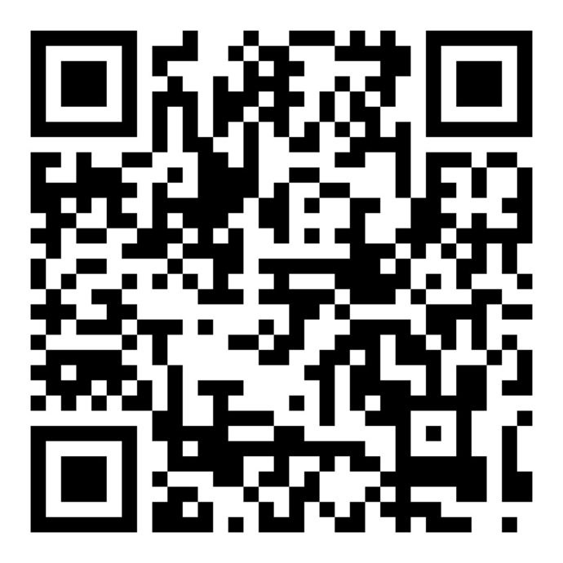

- So Solid Crew, 21 Seconds (2001)

- More Fire Crew, Oi (2002)

- Dizzee Rascal, I Luv U (2003)

- Shystie, I Luv U [Dizzee Rascal Reply] (2003)

- Lethal Bizzle, Pow (2004)

- Wiley, Wot U Call It? (2004)

- Kano, P’s And Q’s (2005)

- JME, Serious (2008)

- Stormzy, WICKEDSENGMAN [part 4] (2015)

- Lady Leshurr, Queen’s Speech 4 (2016)

- Skepta & WizKid, Energy (Stay Far Away) (2018)

- Wiley Sean Paul and Stefflon Don featuring Idris Elba, Boasty (2019)

